Todor Tsekov, George Vasileiadis, Jiefan Lin

Group 6 |

Design Document

Trivia

Table of Contents

1. Architecture diagram 2

2. Interface description 2

2.1 Methods 2

2.2 Callbacks/Events 3

3. Class diagram 3

4. Sequence diagrams 1

4.1 Start game 1

4.2 Answer Question 2

4.3 Win/Lose/Draw 3

# Architecture diagram

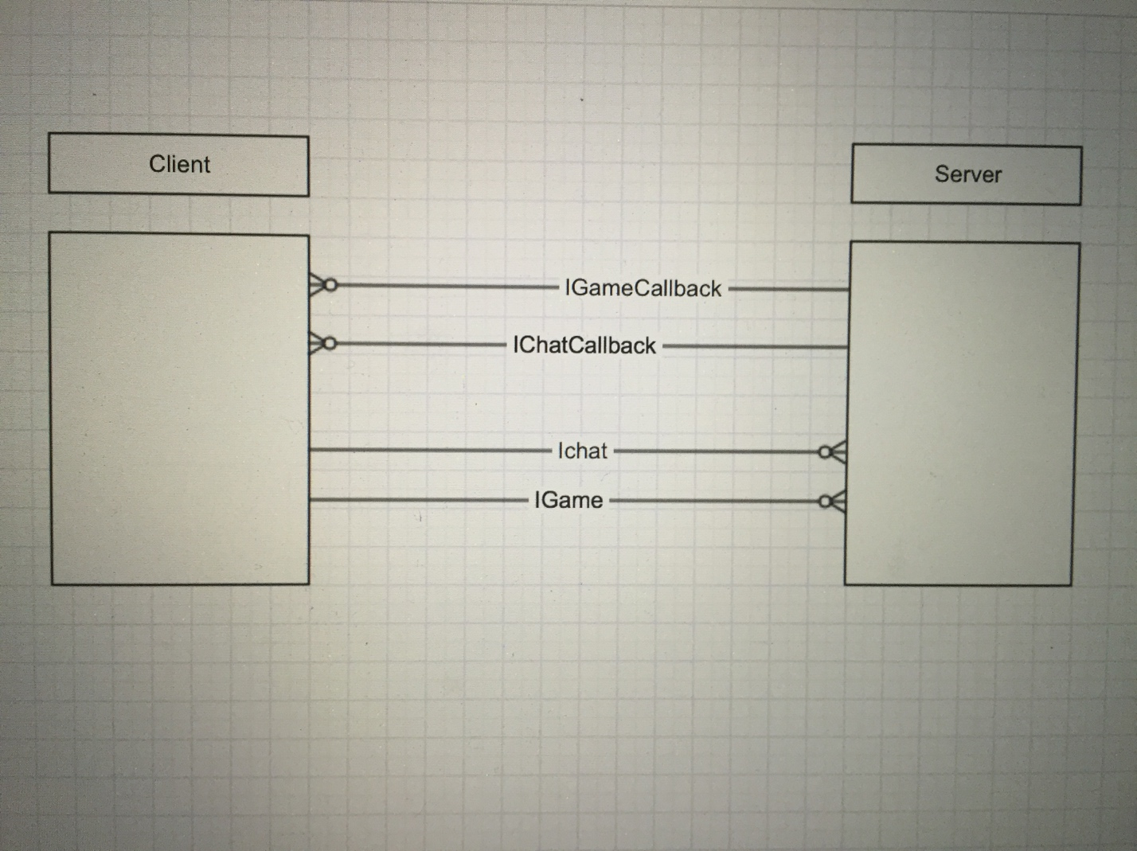

# Interface description

## Methods

The descriptions of the methods are in the application folder inside the server/client projects.

## Callbacks/Events

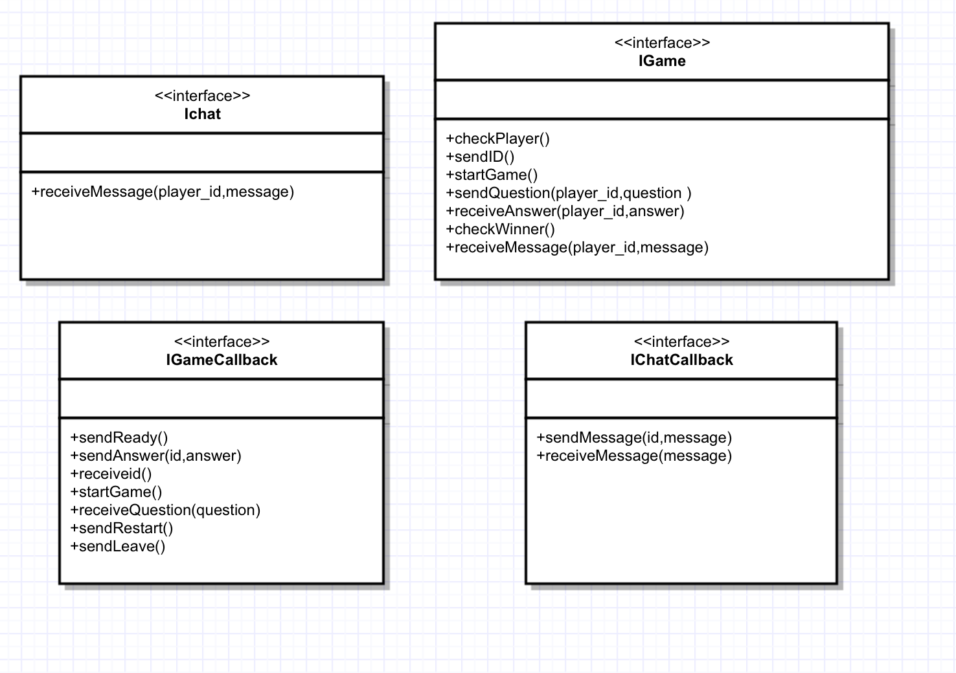

# Class diagram



# Sequence diagrams

## 4.1 Start game

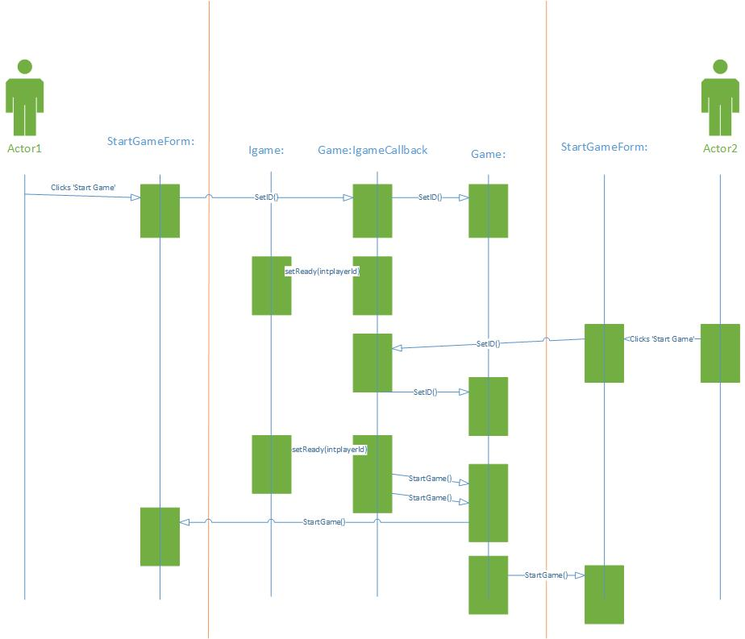

## 4.2 Answer Question

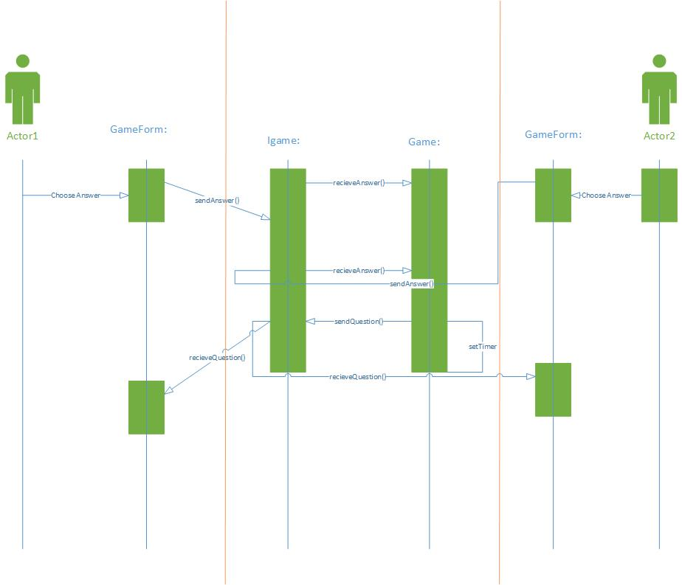

## 4.3 Win/Lose/Draw

